Task on terraform-03
1.Watch the Terraform-03 video.
- Execute the script shown in the video.
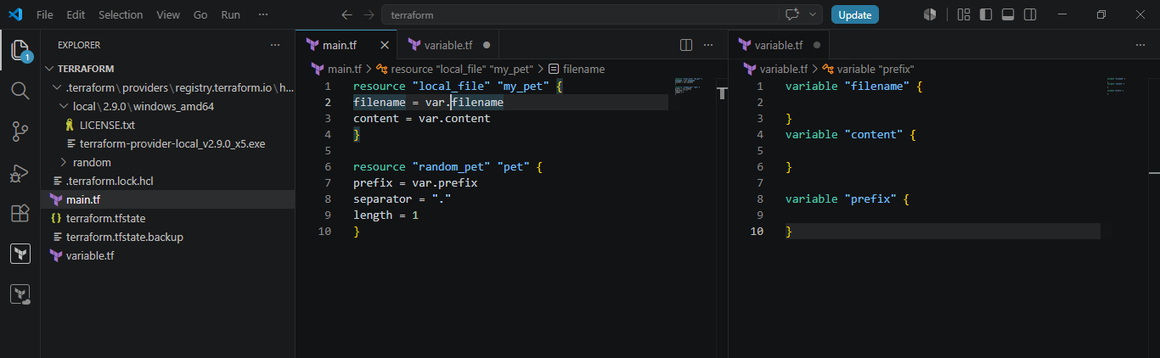
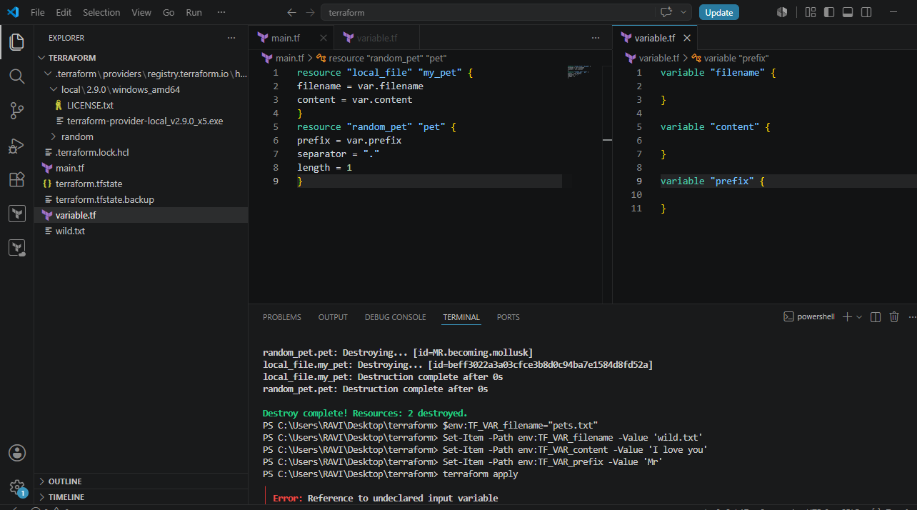
Terraform apply:
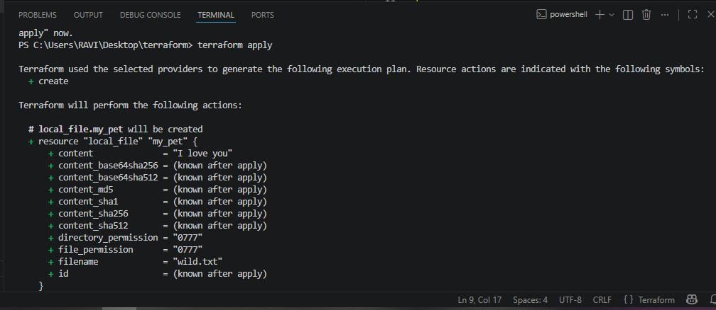
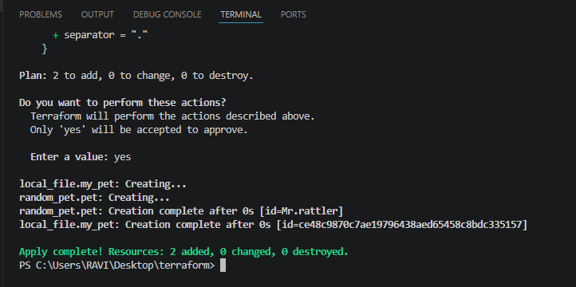
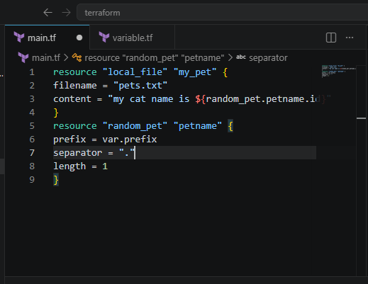
Now save the content in the main.tf file and then hit terraform apply:
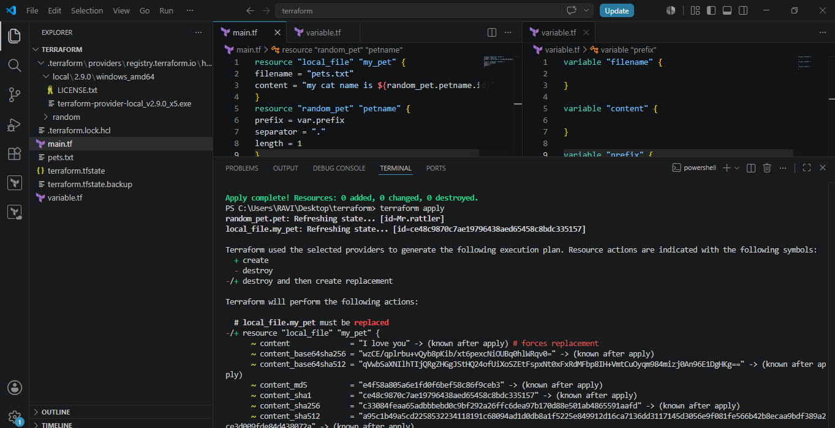
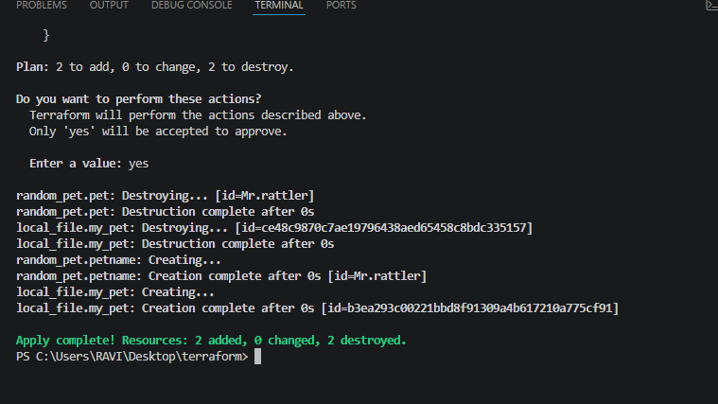
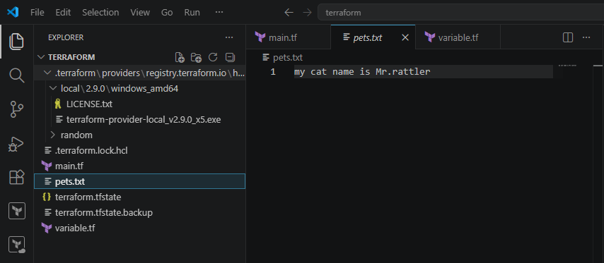
terraform output:
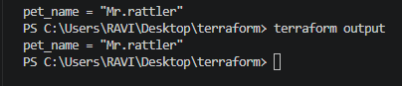
Terraform apply:
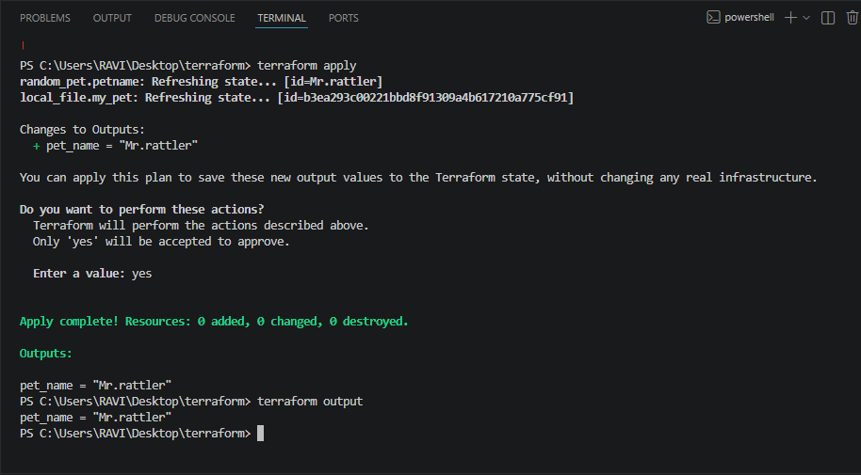
State file: hit terraform show: 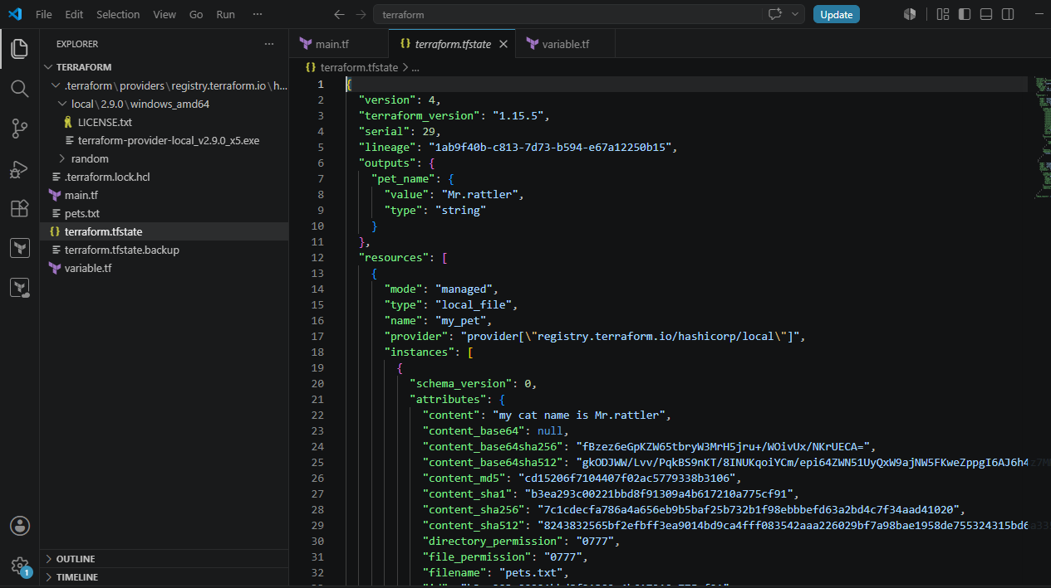
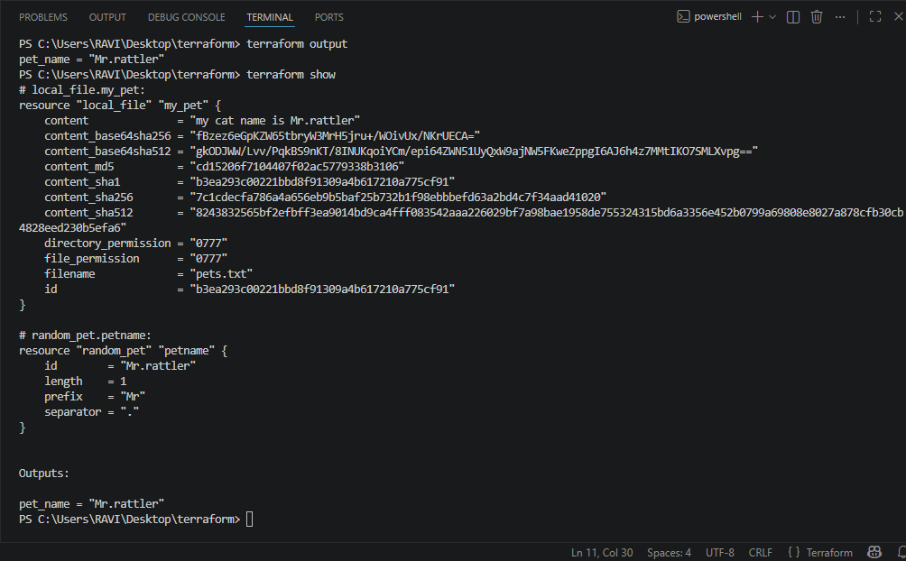
Integrate Terraform in Jenkins using the Terraform plugin.
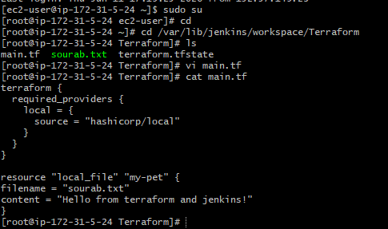
Lets install terraform plugin in Jenkins
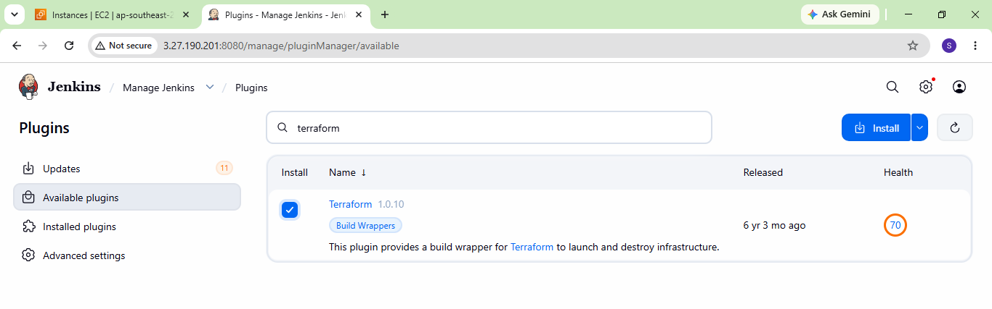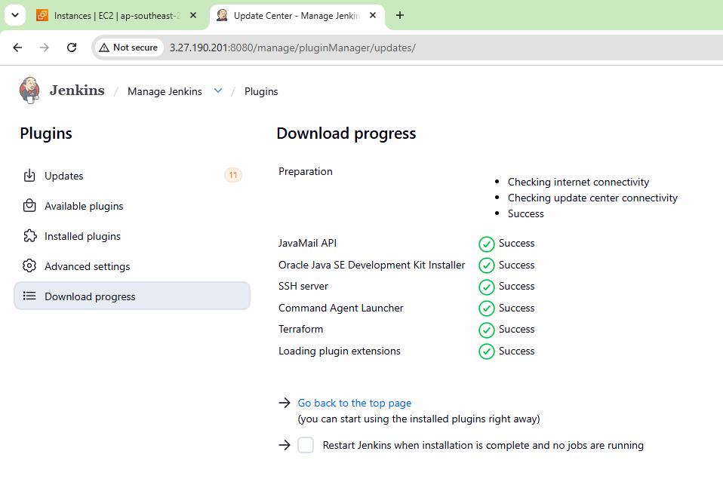 Configure terraform
Tools terraform installation give name save
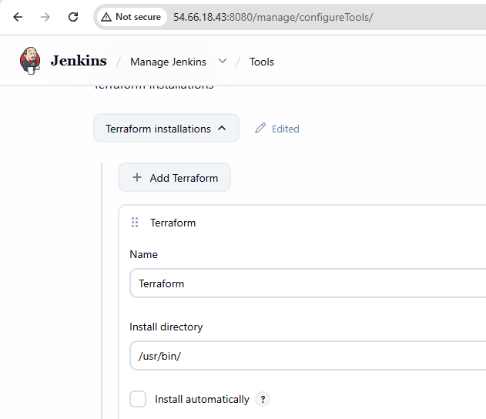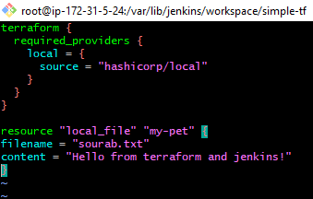
Now lets create a pipeline job
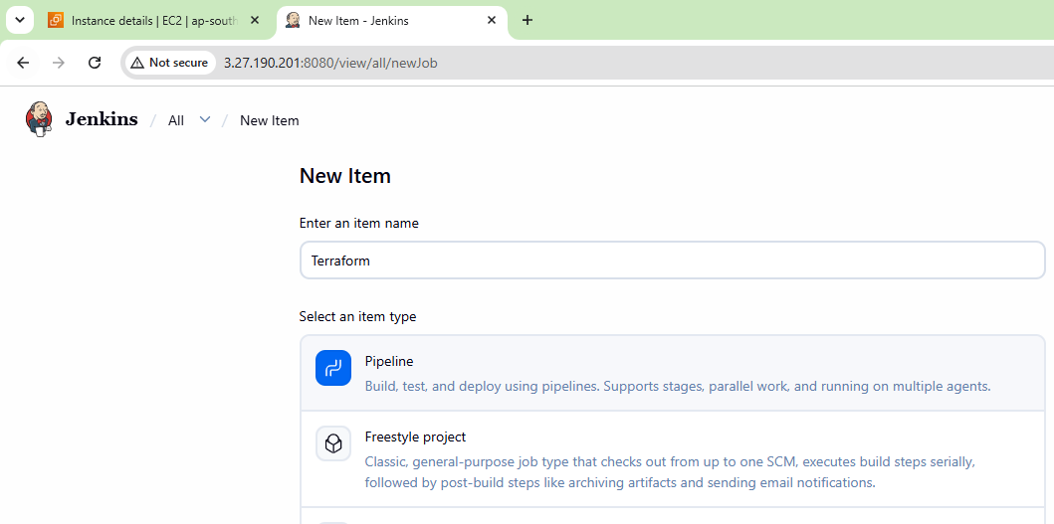write a pipeline script
pipeline {
agent any
stages {
stage('Terraform Init') {
steps {
sh 'terraform init'
}
}
stage('Terraform Plan') {
steps {
sh 'terraform plan'
}
}
stage('Terraform Apply') {
steps {
sh 'terraform apply -auto-approve'
}
}
}
and successfully executed as well:
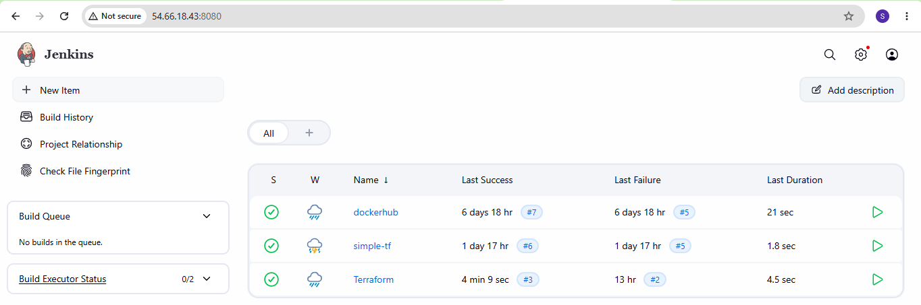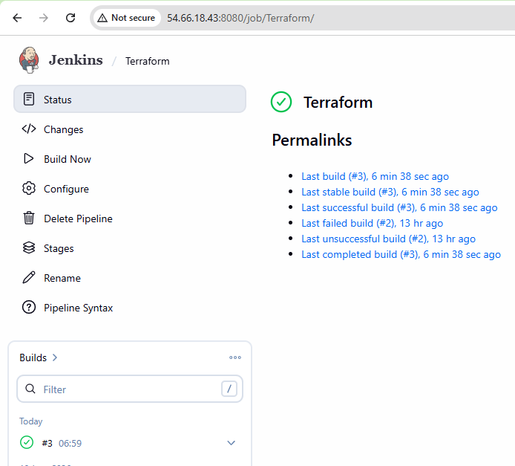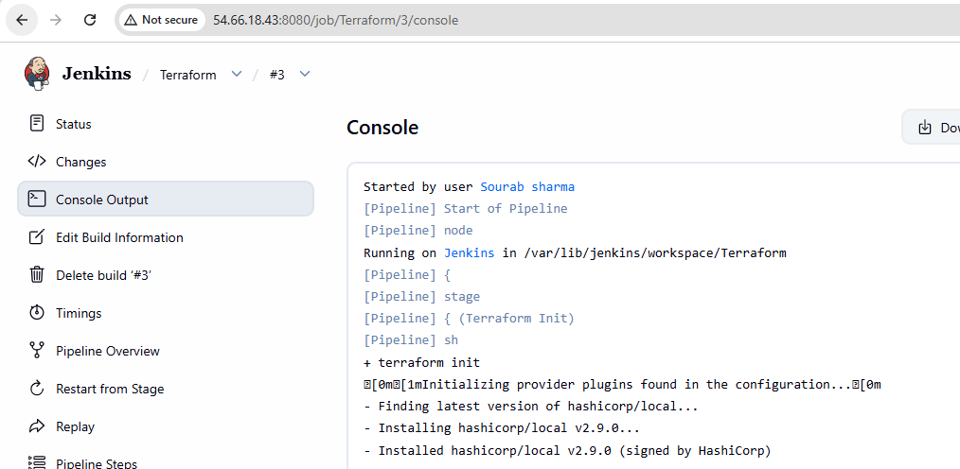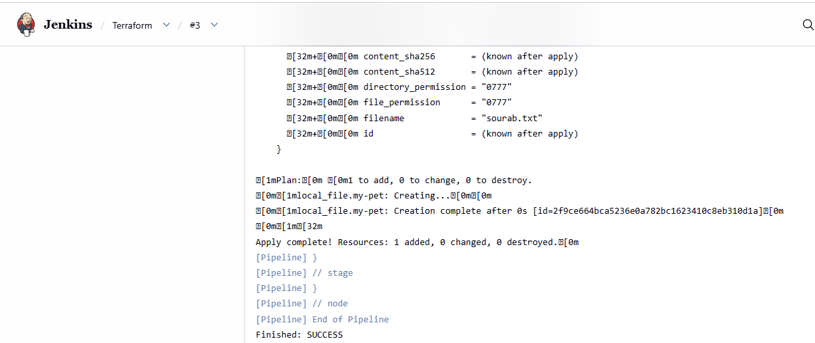 File created successfully:
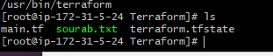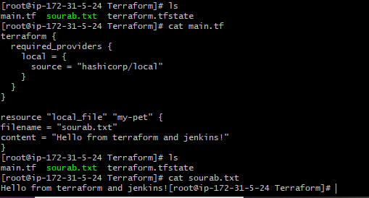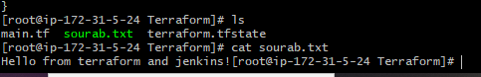
- Create one Jenkins job using Maven Project for the code below with two stages:
  - Stage 1:Git clone
  - Stage 2:Maven CompilationCode:https://github.com/betawins/java-Working-app.git
Install maven integration plugin:
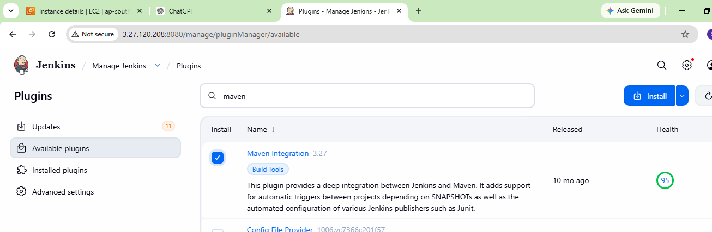
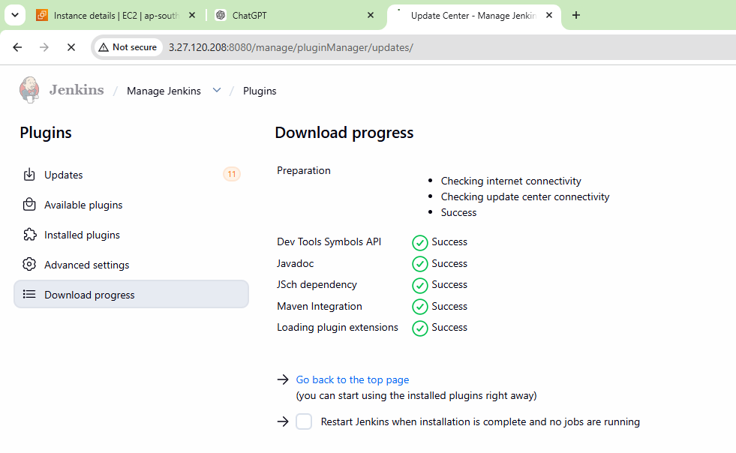 Create paven-project new item: 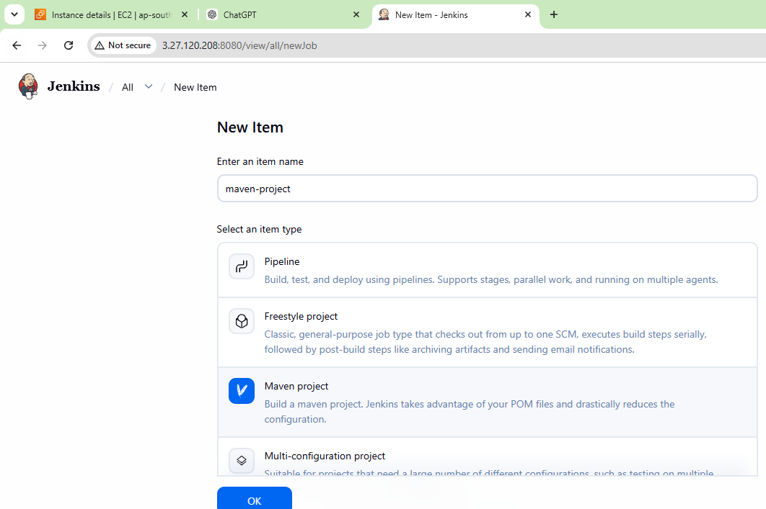 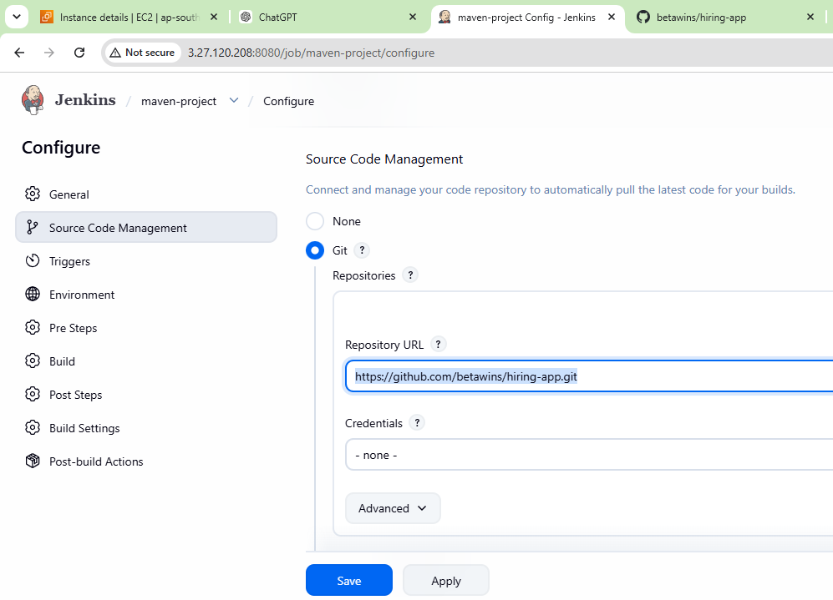 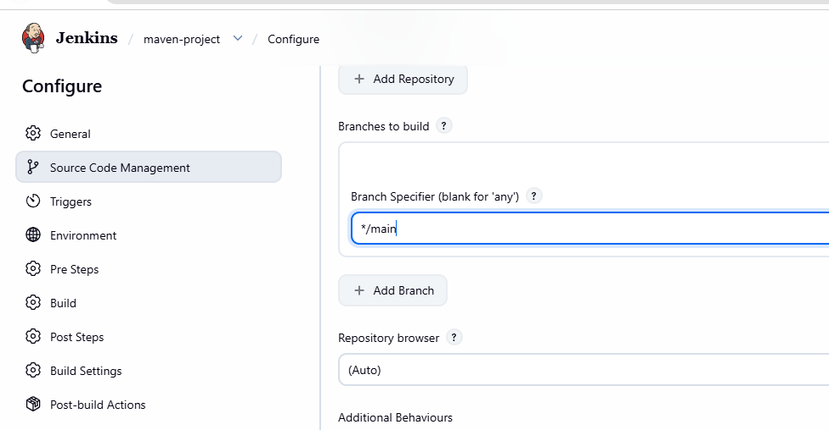
we need to make changes in the manage jenkins and then tools and then add maven in the maven installation step:
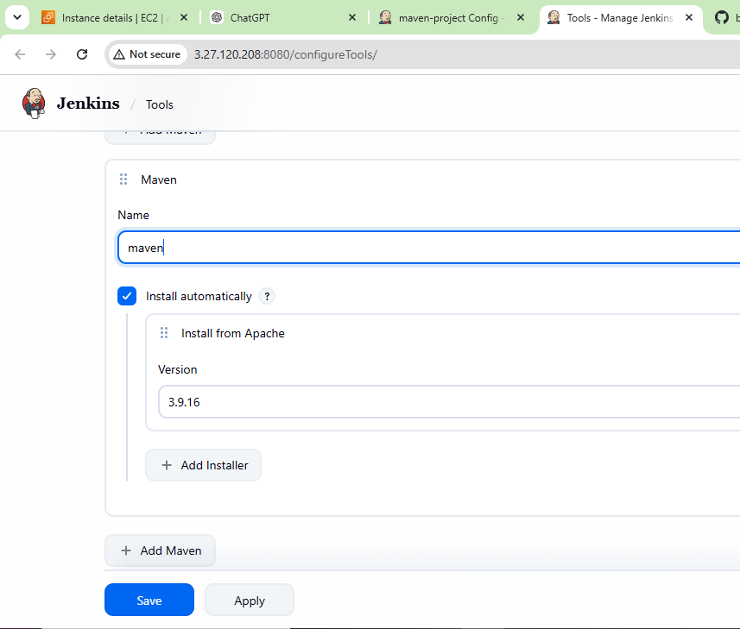
Then go to the main page and then run the by clicking on build now:
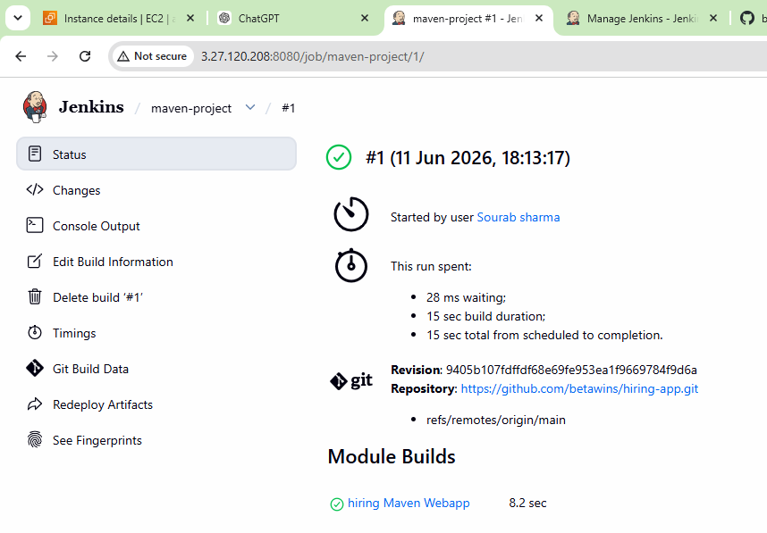 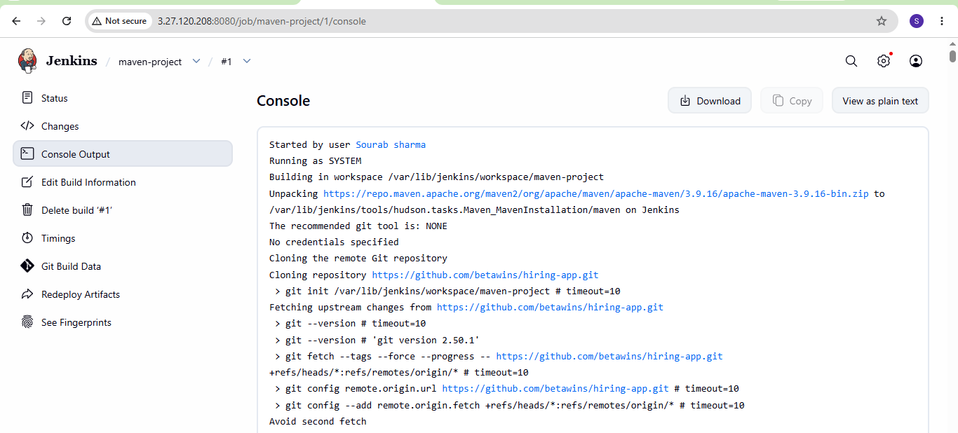 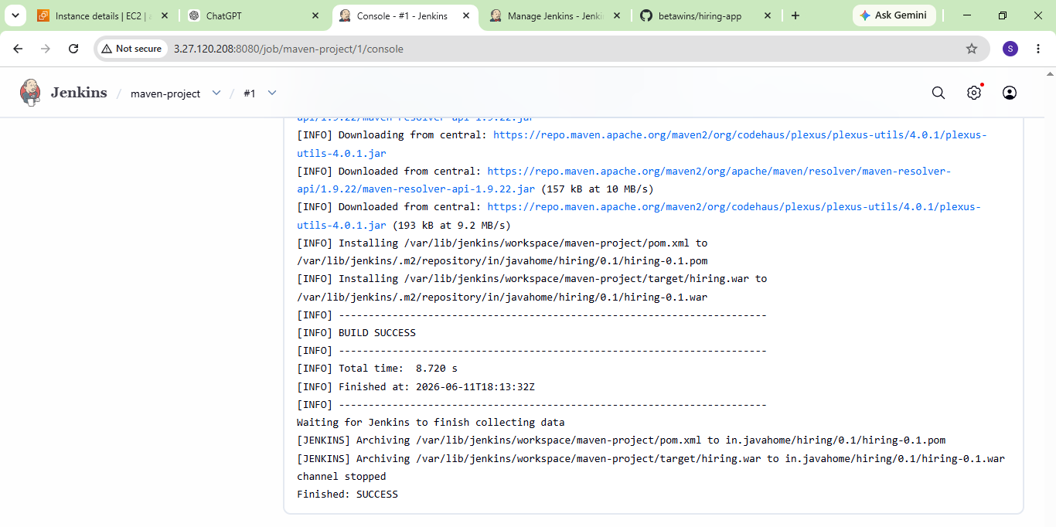
- Use the same code and create a parameterized job in Jenkins with:
  - Stage 1:Git clone
  - Stage 2:Maven CompilationCode:https://github.com/betawins/java-Working-app.git
Lets create a new item in Jenkins:
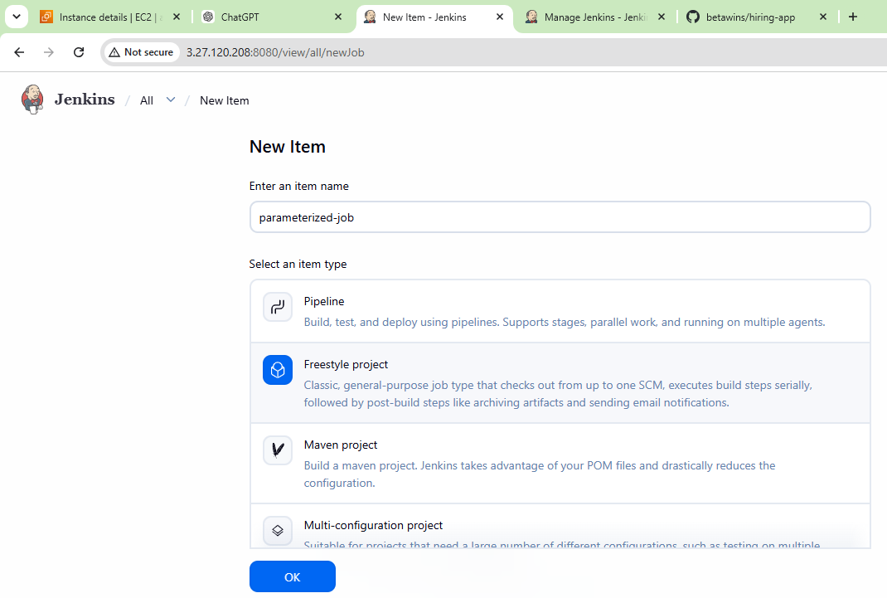
Then add this configuration as shown in the below images:
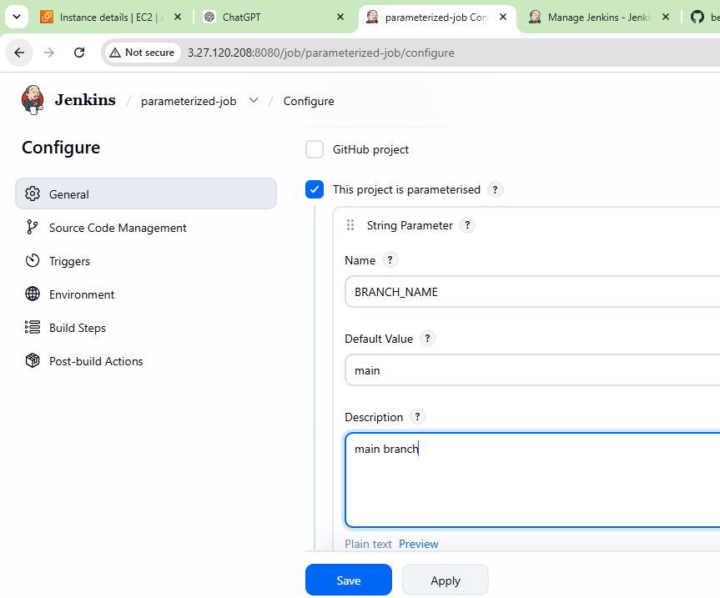 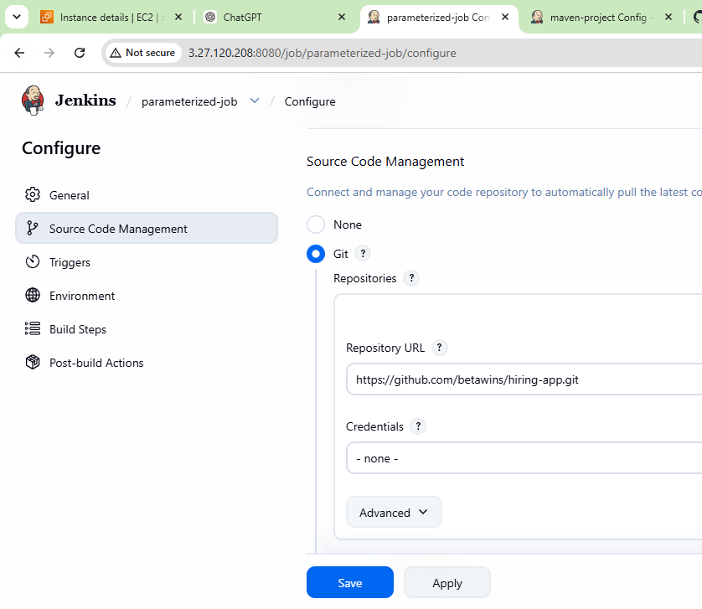
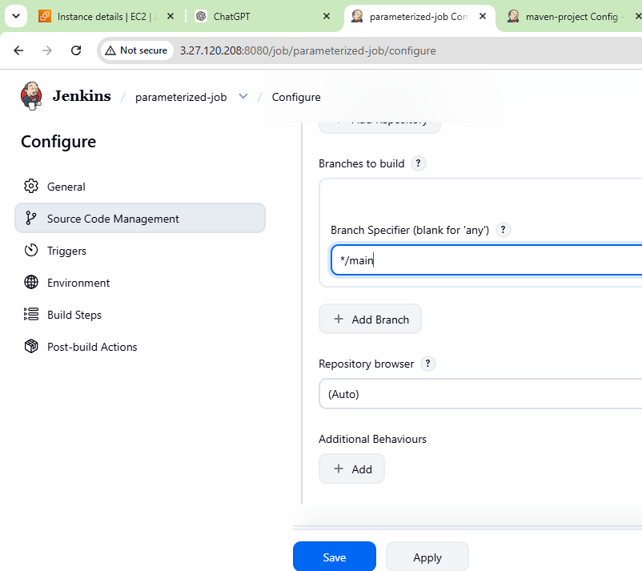
Then go to the main page and then run the by clicking on build with parameters:
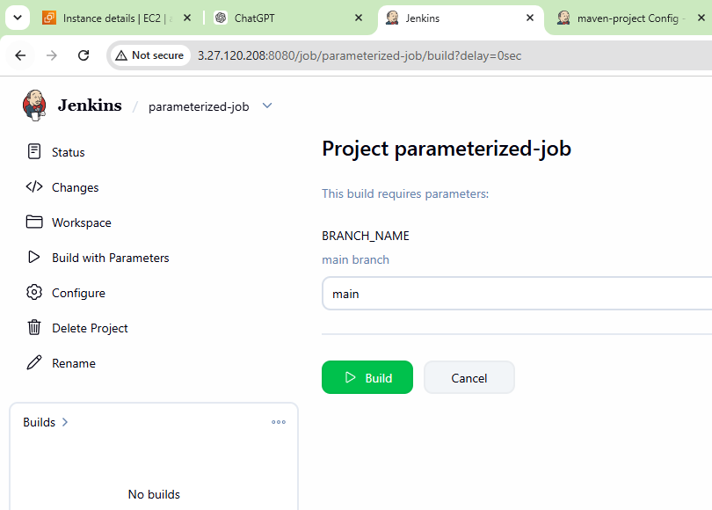
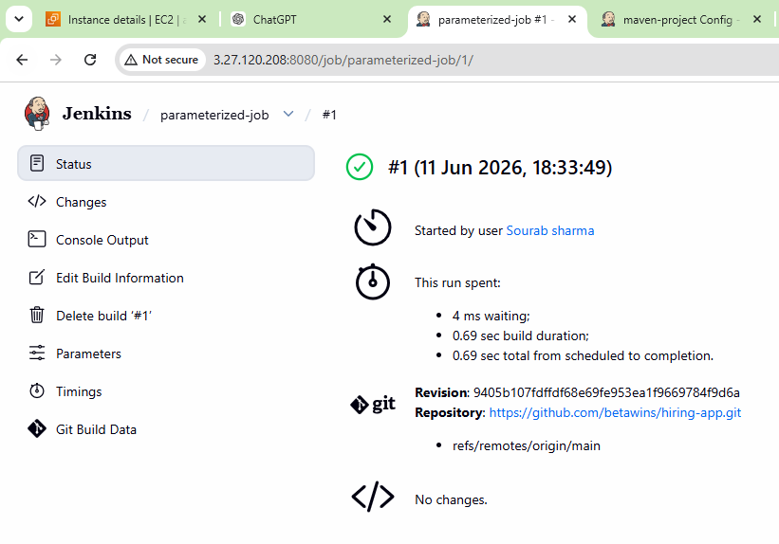
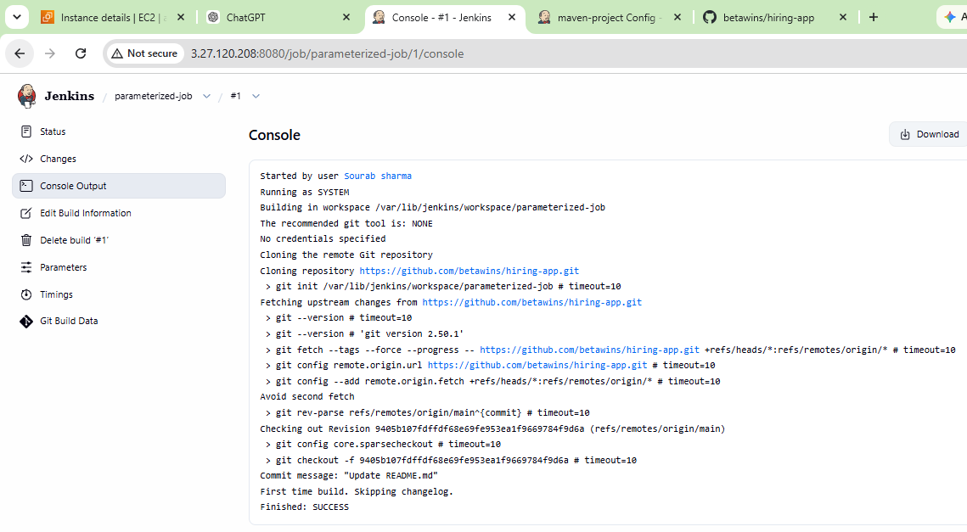
- What are the global variables in Jenkins?
Global variables in Jenkins are predefined environment variables accessible across jobs and pipelines. They provide build-related information such as build number, workspace path, job name, Git branch, and Jenkins home directory.
Some commonly used global variables include :-
BUILD_NUMBER, which stores the current build number,
JOB_NAME, which contains the name of the Jenkins job,
WORKSPACE, which defines the location where Jenkins clones the source code and executes builds.
Variables like GIT_COMMIT and GIT_BRANCH help identify the exact Git commit and branch used during the build process.
These global variables are useful in automation, scripting, and CI/CD pipelines to make Jenkins jobs more dynamic and reusable.

